COURSE: Coursera IBM Data Science Professional Certification

**Finding Similar Neighbourhood to Migrate.**

A Simple inter-city or intra-city Recommender System

horizontal line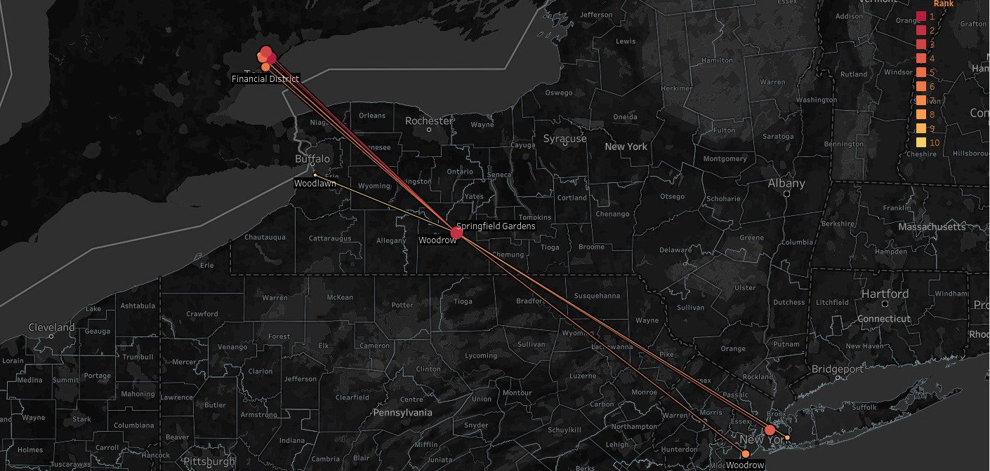

Github link: <https://github.com/sagarrathi/Coursera_Capstone/blob/master/Capstone/Finding%20Similar%20Cities%20to%20Migrate.ipynb>

Tableau Dashboard: [https://sagarrathi.github.io](https://sagarrathi.github.io/)

# Table Of Contents

**Table Of Contents** **2**

**1. Introduction** **3**

1.1. Background 3

1.2. Problem 3

1.3. Target Audience 3

**2. Data** **4**

2.1. What data do we need? 4

2.1.1. Scraping neighbourhood and borough details from Wiki & other websites 5

2.1.2. Getting Location Data OpenStreetMap API Nominatim 6

2.2. Preprocessing Data for modelling 7

2.2.1. Removing rows with empty cells 7

2.2.2. Converting Category column to one-hot encoding 7

2.3. Describing Data 9

2.3.1. Describing data's X 9

2.3.2. Describing data's y 9

**3. Methodology** **10**

3.1 Exploratory Data Analysis 10

3.1.1 Finding correlation between feature sets 10

3.1.2 Finding box plot of Data’s X 11

3.1.3 City wise number of venues 12

3.1.4 City wise venus's composition. 13

3.2 Choosing Technique 14

3.3 Applying Technique 14

3.2.1 Normalization 14

3.2.2 Multiplication 14

3.2.3 Finding top 10 Recommendation 14

**4. Result** **15**

**5. Discussion** **17**

**6. Conclusion** **18**

# 

# 1. Introduction

## 1.1. Background

We all love Spotify or many of us do. Spotify has offices in New York (USA) and Toronto (Canada).

Suppose the company decides to shuffle some of its employees between two cities, and James(employee) of NYC and Thomas(employee) of Toronto are being told exchange themselves between offices in lieu of pay rise.

Both James and Thomas agree to exchange for the benefit of a pay rise.

## 1.2. Problem

The problem is that both are very stubborn people. They think that they will be able to find the most similar environment in both of these cities.

After doing hard research they fail and they give up the task of exchanging places. So the HR of the company has asked us to solve this problem or to find suitable (similar) alternate neighbourhood between these two cities.

We ask HR, what does he/she mean by similar neighbourhood?

The HR told us that they need similar cities on the basis of leaving condition and amenities present in the surrounding area.

So, our task here is to find similar neighbourhood in and outside of the city and give recommendation to HR so that the next time they do some shuffling at least they will have data and can recommend a suitable neighbourhood to the employee.

## 1.3. Target Audience

Our target audience is various HR who want to send their employees to different cities and also various people who want to shift cities and do not know where to go being very stubborn of choices.

# 2. Data

## 2.1. What data do we need?

Our problem statement has made a very vague suggestion on similar cities. What data we need in this project can be listed by asking right questions………... and answering them too.

|  |  |  |
| --- | --- | --- |
| No. | Questions | Answers |
| 1 | Do you know the name of the neighbourhood and boroughs of cities? | We do not know yet but Wikipedia and other websites have published all of this data, so we will scrape that data. |
| 2 | Before obtaining any data on amenities around do you know the exact GPS coordinates of those places? | We don’t remember GPS coordinate of own home but in this case, Open Street Map and Google Map know all about this data, so we will use their API (geopy) to solve this problem. |
| 3 | Ok great that you know GPS coordinate but do know what paces are nearby that location like garden, parks, hotels and etc. | To be honest, I am a couch potato, I don’t know the name of the restaurant nearby my neighbour but I often use the Foursquare app to explore any place, I heard that they have API too and we can get a large amount of data from those API. So we will use the foursquare API. |

It seems that we have answers for all our data retrieval needs. Let us try those answers and see what we get.

### 2.1.1. Scraping neighbourhood and borough details from Wiki & other websites

For Toronto we obtain 174 data points with the format as follows:

|  |  |  |  |
| --- | --- | --- | --- |
|  | **Neighbourhoods** | **Boroughs** | **City** |
| 0 | Agincourt | Scarborough | TOR |
| 1 | Alderwood | Etobicoke | TOR |
| 2 | Alexandra Park | Old City of Toronto | TOR |
| 3 | Allenby | Old City of Toronto | TOR |
| 4 | Amesbury | North York | TOR |

For New York we obtain 329 data points with the format as follows:

|  |  |  |  |
| --- | --- | --- | --- |
|  | **Neighborhoods** | **Boroughs** | **City** |
| 0 | Bath Beach | Brooklyn | NYC |
| 1 | Allerton | Bronx | NYC |
| 2 | Battery Park City | Manhattan | NYC |
| 3 | Arverne | Queens | NYC |
| 4 | Annadale | Staten Island | NYC |

We merge these two data set to obtain a common data frame. And continue to obtain GPS coordinates of each location(neighbourhood).

### 2.1.2. Getting Location Data OpenStreetMap API Nominatim

Here we use geopy library of python to search for latitude and longitude of each neighbourhood. This data is necessary for further retrieving data from foursquare. We obtain the following data:

|  |  |  |  |  |  |
| --- | --- | --- | --- | --- | --- |
|  | Neighbourhoods | Boroughs | City | Latitude | Longitude |
| 0 | Bath Beach | Brooklyn | NYC | 40.6018495 | -74.000501 |
| 1 | Allerton | Bronx | NYC | 40.8661111 | -73.8505556 |
| 2 | Battery Park City | Manhattan | NYC | 40.7110166 | -74.0169369 |
| 3 | Arverne | Queens | NYC | 40.5934173 | -73.7895462 |
| -------- | --------------------- | ------------------ | ----- | ---------------- | ---------------- |
| 163 | Westminster | North York | TOR | 41.1970392 | -73.8451355 |
| 164 | Westmount | Etobicoke | TOR | 40.5731606 | -74.094586 |
| 165 | Weston | York | TOR | 42.7684005 | -75.7365767 |
| 166 | Wexford | Scarborough | TOR |  |  |
| 167 | Willowdale | North York | TOR |  | -73.469407 |

## 2.2. Preprocessing Data for modelling

### 2.2.1. Removing rows with empty cells

Empty cells in GPS coordinates of the neighbourhood will not render in the map so we will delete such cell.

Also, cells without a category will be useless for classification so must be deleted too.

On command: df.isnull().sum() we get:

* Neighborhoods 0
* Boroughs 0
* City 0
* Latitude 0
* Longitude 0
* Venue 0
* Category 0
* VenueLat 0
* VenueLong 0

Hence no incomplete rows.

### 2.2.2 Reducing number of categories or features set.

We have 477 categories which is very large and redundant.

One way to solve this issue is to push up the child categories to parent categories as this will reduce the number of categories we have to deal with.

We do this by finding the categories structure from foursquare which looks like below:

Arts & Entertainment

|-> Amphitheater

|-> Movie Theater

|-> Drive-in Theater

|-> Indie Movie Theater

We have 5 levels of category so we start by converting level 5 category to level and level 4 to level 3 and so on.

On Converting level: 5 to 4 we obtain no change.

On Converting level: 4 to 3 we reduce category by 18.

On Converting level: 3 to 2 we reduce category by 121.

On Converting level: 2 to 1 we reduce category by 293.

And thus we convert 477 categories to mere 10 major categories.

### 2.2.3. Converting Category column to one-hot encoding

Since we would like to know the number of times each category occurred in the neighborhood we will convert category column to one-hot encoded columns.

|  |  |  |  |  |  |  |  |  |  |  |  |  |  |  |  |  |
| --- | --- | --- | --- | --- | --- | --- | --- | --- | --- | --- | --- | --- | --- | --- | --- | --- |
|  | **Neighborhoods** | **Boroughs** | **City** | **Latitude** | **Longitude** | **Venue** | **VenueLat** | **VenueLong** | **Arts & Entertainment** | **College & University** | **Event** | **Food** | **Nightlife Spot** | **-----** | **Residence** | **Shop & Service** |
| 0 | East New York | Brooklyn | NYC | 40.66677 | -73.882358 | D'compadres | 40.666623 | -73.882174 | 0 | 0 | 0 | 0 | 0 | **-----** | 0 | 1 |
| 1 | East New York | Brooklyn | NYC | 40.66677 | -73.882358 | Torres Hardware | 40.666584 | -73.882608 | 0 | 0 | 0 | 0 | 0 | **-----** | 0 | 1 |

Now we group data by neighbourhoods and calculate the mean of their categories to obtain the ratio of presence of a particular category in a Neighbourhood. We further remove other columns to obtain what we call as features or X.

|  |  |  |  |  |  |  |  |  |
| --- | --- | --- | --- | --- | --- | --- | --- | --- |
|  | **Neighborhoods** | **City** | **Latitude** | **Longitude** | **VenueLat** | **VenueLong** | **Arts & Entertainment** | **College & University** |
| 0 | Agincourt | TOR | 43.785353 | -79.278549 | 43.787123 | -79.274425 | 0.033333 | 0 |
| 1 | Alderwood | TOR | 43.601717 | -79.545232 | 43.601361 | -79.545082 | 0.033333 | 0 |
| 2 | Alexandra Park | TOR | 43.650758 | -79.404298 | 43.651561 | -79.404832 | 0 | 0 |

X:

|  |  |  |  |  |  |  |  |  |  |  |
| --- | --- | --- | --- | --- | --- | --- | --- | --- | --- | --- |
|  | **Arts & Entertainment** | **College & University** | **Event** | **Food** | **Nightlife Spot** | **Outdoors & Recreation** | **Professional & Other Places** | **Residence** | **Shop & Service** | **Travel & Transport** |
| 0 | 0.033333 | 0 | 0 | 0.4 | 0 | 0.033333 | 0.2 | 0 | 0.3 | 0.033333 |
| 1 | 0.033333 | 0 | 0 | 0.233333 | 0.033333 | 0.133333 | 0.233333 | 0 | 0.333333 | 0 |
| ... | ... | ... | ... | ... | ... | ... | ... | ... | ... | ... |
| 165 | 0.047619 | 0.047619 | 0 | 0 | 0 | 0.047619 | 0.380952 | 0 | 0.333333 | 0.142857 |
| 166 | 0.047619 | 0 | 0 | 0.142857 | 0.142857 | 0.190476 | 0.047619 | 0 | 0.380952 | 0.047619 |

Each row of above data signify a neighbourhood and each column the ratio of the particular category in that neighbourhood.

## 2.3. Describing Data

It would have been completely in vain, had we described the data without even retrieving them first. Now that we already have the data we can easily describe them.

### 2.3.1. Describing data's X

Our data has the following columns:

Arts & Entertainment | College & University | Event | Food | Nightlife Spot | Outdoors & Recreation | Professional & Other Places | Residence | Shop & Service | Travel & Transport

### 2.3.2. Describing data's y

Since we do not have labelled data we will use unsupervised learning and hence we do not have any dependent variable y as it will be decided by model.

# 

# 3. Methodology

## 3.1 Exploratory Data Analysis

### 3.1.1 Finding correlation between feature sets

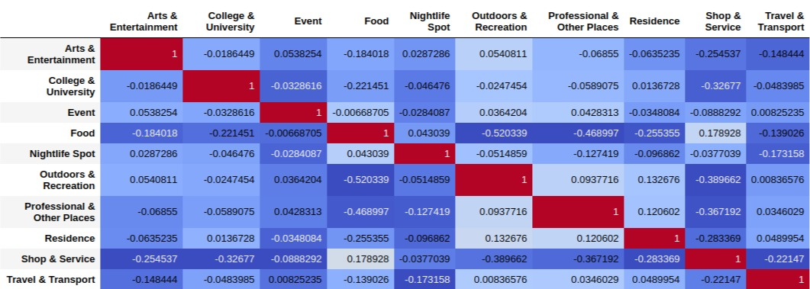

* A good thing to note is that we do not have any significant correlation among our feature set, so we can easily proceed further.

### 3.1.2 Finding boxplot of Data’s X

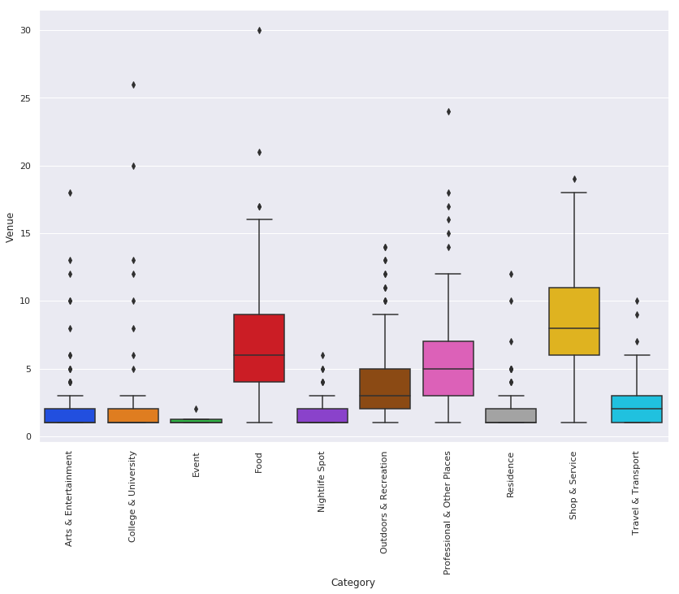

* We notice that venues like Food and Shops are more present than other category, this could have been due to particular city having more number of such venues, but since we do not know in certain, we try to find this by making barplot of city wise & venue wise.

### 3.1.3 City wise number of venues

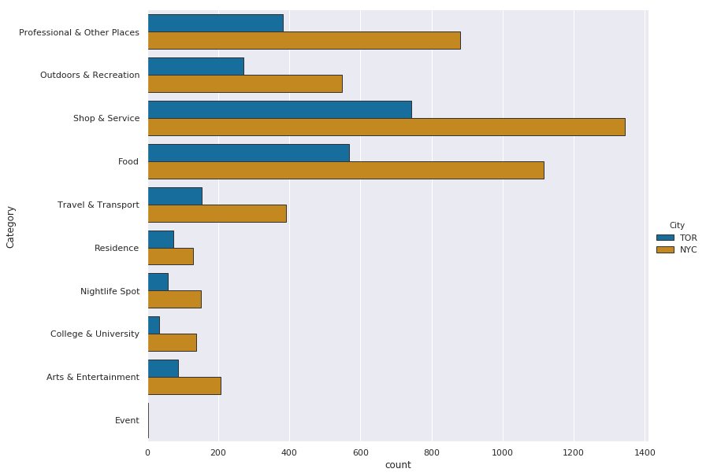

* The most interesting part of this graph is that for both cities on total level the composition of venues are similar.So our previous hypothesis that a particular city might be having more number of shop and food in different composition is rejected.
* Also in every venue category New York has almost double the amount of venus compared to that of Toronto, but the composition is almost similar. Which we can clarify using pie chart of both this city separately side by side.

### 3.1.4 City wise venus's composition.

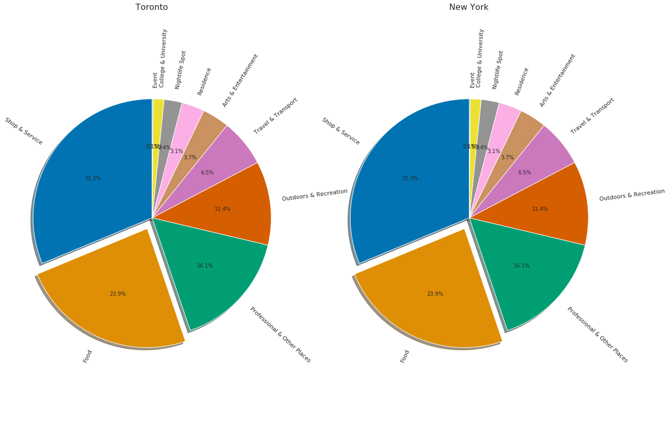

* We notice that with every venue, the composition of venue has remained the same in cities although New York have double the amount of venue.
* Thus our techniques of scoring by the method of recommender system will never yield more than 50% of similarity score as New York will always be twice denser than new Toronto.

## 3.2 Choosing Technique

There are two ways for us to solve the issue of classification:

1. K-Means: Because we have unlabeled data and we can form clusters. But since we have 417 column or features set with many empty columns, the euclidean distance will always be very less and thus many places will will miss classified.
2. Recommender System: While it may be argued that we do not have ratings of places, then how do we use recommender system. This issue can easily be mitigated because sum of similar venues in particular neighborhood represent the composition of particular neighbourhood, hence we have already have a weighted genre/type of venue with us.

## 3.3 Applying Technique

### 3.2.1 Normalization

The problem with our data is that while some neighborhood may have more venues other may have, what we seek is their underlying composition so we normalize the rows.

### 3.2.2 Multiplication

Now we multiply the normalized row to the data frame.

### 3.2.3 Finding top 10 Recommendation

Now we sum up all the columns row wise to obtain row score, and find the 10 places with the highest score.

# 4. Result

We obtain a result as follows:

|  |  |
| --- | --- |
| Columns | Their Meaning |
| 'neighborhood' | Neighborhood for which we need recommendation. |
| 'City' | City of Neighborhood for which we need recommendation. |
| 'latitude', 'longitude' | Location of Neighborhood for which we need recommendation. |
| 'm_neighborhood', | Neighborhood recommended by the program. |
| 'm_city', | City of Neighborhood recommended by the program. |
| 'm_latitude', 'm_longitude', | Location of Neighborhood recommended by the program. |
| 'rank', | Rank of recommendation whether it is best or second best or 9th best. Ex. 4 means 4th best recommended place. |
| 'score' | Score obtained by place on sum of matrix multiplication. Higher scores represent highly recommended. |
| 1,2,3,4,...10 | This columns list the venue according to their rating. So venue in column 1 has more occurrence in in particular 'm_neighborhood' |
| 1v,2v,3v,4v,...10 | This columns list the venue’s rating according to their rank of previous column. It tells how good match we have obtained for venue in category. |

|  |  |  |  |  |  |  |  |  |  |  |  |  |  |  |  |
| --- | --- | --- | --- | --- | --- | --- | --- | --- | --- | --- | --- | --- | --- | --- | --- |
|  | **neighborhood** | **city** | **latitude** | **longitude** | **m_neighborhood** | **m_city** | **m_latitude** | **m_longitude** | **rank** | **score** | **...** | **5** | **5v** | **6** | **6v** |
| 0 | Allerton | NYC | 40.866111 | -73.850556 | Eglinton East | TOR | 43.739622 | -79.23229 | 1 | 0.176923 | ... | Food | 0.076923 | College & University | 0.076923 |
| 1 | Allerton | NYC | 40.866111 | -73.850556 | Sheepshead Bay | NYC | 40.591216 | -73.944582 | 2 | 0.17619 | ... | Food | 0.071429 | Residence | 0.035714 |

We validate our assumption about the score been less than 0.5 as mentioned in our EDA section and make normal plot of score as shown below:

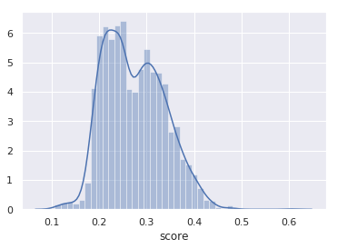

Thus we have scores ranging from 0.2 to 0.4 as shown above.

# 5. Discussion

We note that our recommendation system is unable to yield a score above 0.5, the reason for which was found by performing EDA analysis. EDA analysis proved that New York and Toronto have similar composition of venues but New York has almost twice the amount of venues than that of Toronto.

While we were about to choose K-means clustering, the algorithm would have stripped away various essential data as we see in recommendation system that we have top 10 neighborhoods suggestion with score ranging from 0.48 to 0.1. The amount of similarity which we gain in recommendation system would have been not present in case of K-means clustering.

For every Neighbhouurhood not only do we recommend top 10 similar neighborhood but also the features or venue composition along with their ranking and score.

We could have easily just multiplied the the results of Toronto by 2 to compensate for the density but we are not doing it as it may cause data loss.

A better Neural Network technique could have been used because we had 477 Categories label for venue but since we have only 181 Neighbourhood data points it would have been a wrong choice. Hence the 477 Categories label were merged to form only 10 categories label. May be in future by having a large number of dataset we can easily use neural network.

The most fundamental problem in our project was that we did not include population density and other economic parameters for the reason that we only focused on comparing places based on their venue composition structure. Using other economic parameter would have been another project altogether.

# 

# 

# 6. Conclusion

What we learn from this project is that recommendation system can also be used for unlabeled data, which we have performed successfully in this project.

A better way to conclude this report would have been to make a Tableau Story which can easily suggest places to people looking for a new place to live. The link of which can be found here:[https://sagarrathi.github.io](https://sagarrathi.github.io/)